Name: Sanika Botre PRN: 25070122063
Batch: 2025-29 Branch: CSE A-2
Subject: Programming with Java

ASSIGNMENT No: 5

TITLE : Develop a Java application demonstrating the use of ArrayList, Vector, and StringBuffer for dynamic data storage, management, and string manipulation.

Problem Statement: Develop a Java application demonstrating the use of ArrayList, Vector, and StringBuffer for dynamic data storage, management, and string manipulation.

Learning Objectives: To implement dynamic data storage and string manipulation using ArrayList, Vector, and StringBuffer.

Theory:

ArrayList and Vector are dynamic array implementations provided by the Java Collections Framework. ArrayList offers faster performance in single-threaded applications, whereas Vector provides synchronized operations for thread safety. StringBuffer is a mutable sequence of characters that allows efficient string modification without creating new objects. These classes are commonly used in applications requiring dynamic memory allocation and efficient string processing.

Exercise:

1. Create a To-Do List application using ArrayList to store tasks and StringBuffer to display tasks.

Code:-

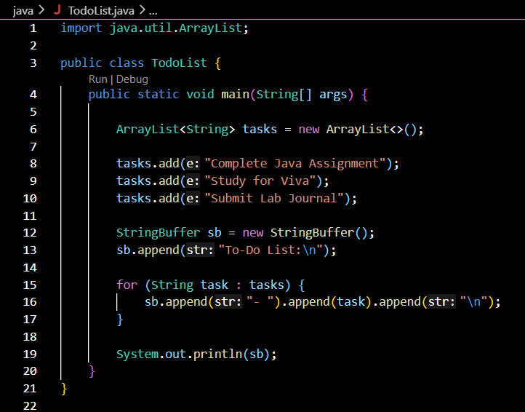

Output:-

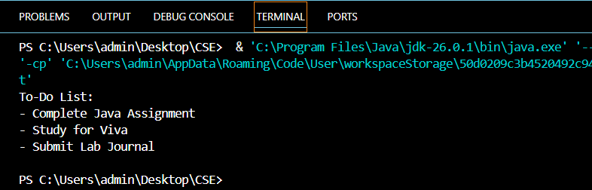

2. Create a Student Course Registration System using ArrayList to store the list of courses registered by a student and StringBuffer to generate and display the registered course list. The application should allow users to add, remove, and view registered courses.

Code:-

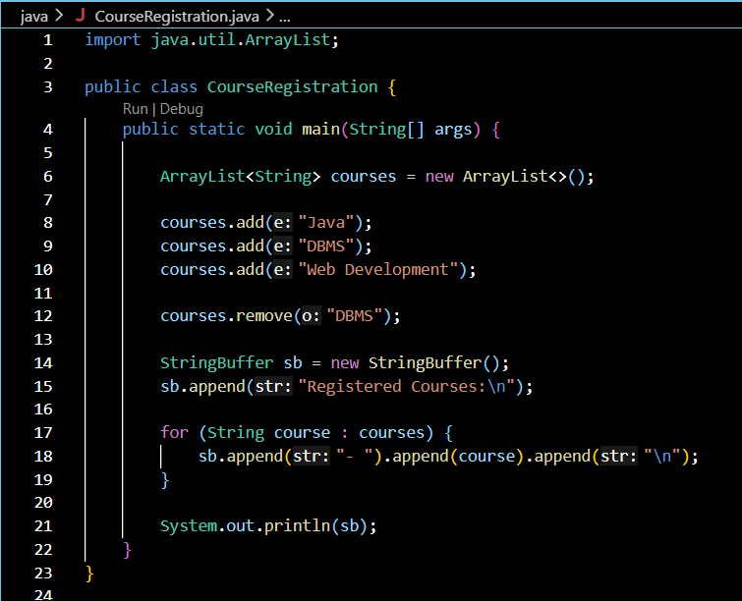

Output:-

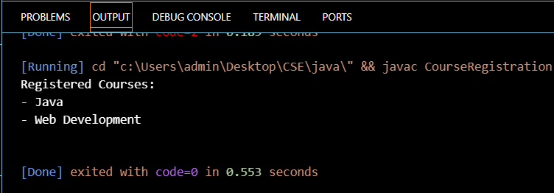

Conclusion:

This assignment successfully demonstrated the use of ArrayList and StringBuffer in Java. ArrayList was used to store and manage data dynamically, while StringBuffer was used for efficient string creation and modification. The programs successfully performed operations such as adding, removing, and displaying data. This assignment improved the understanding of Java Collection Framework, string manipulation, and the development of efficient and user-friendly applications.

